**CPEN 291**

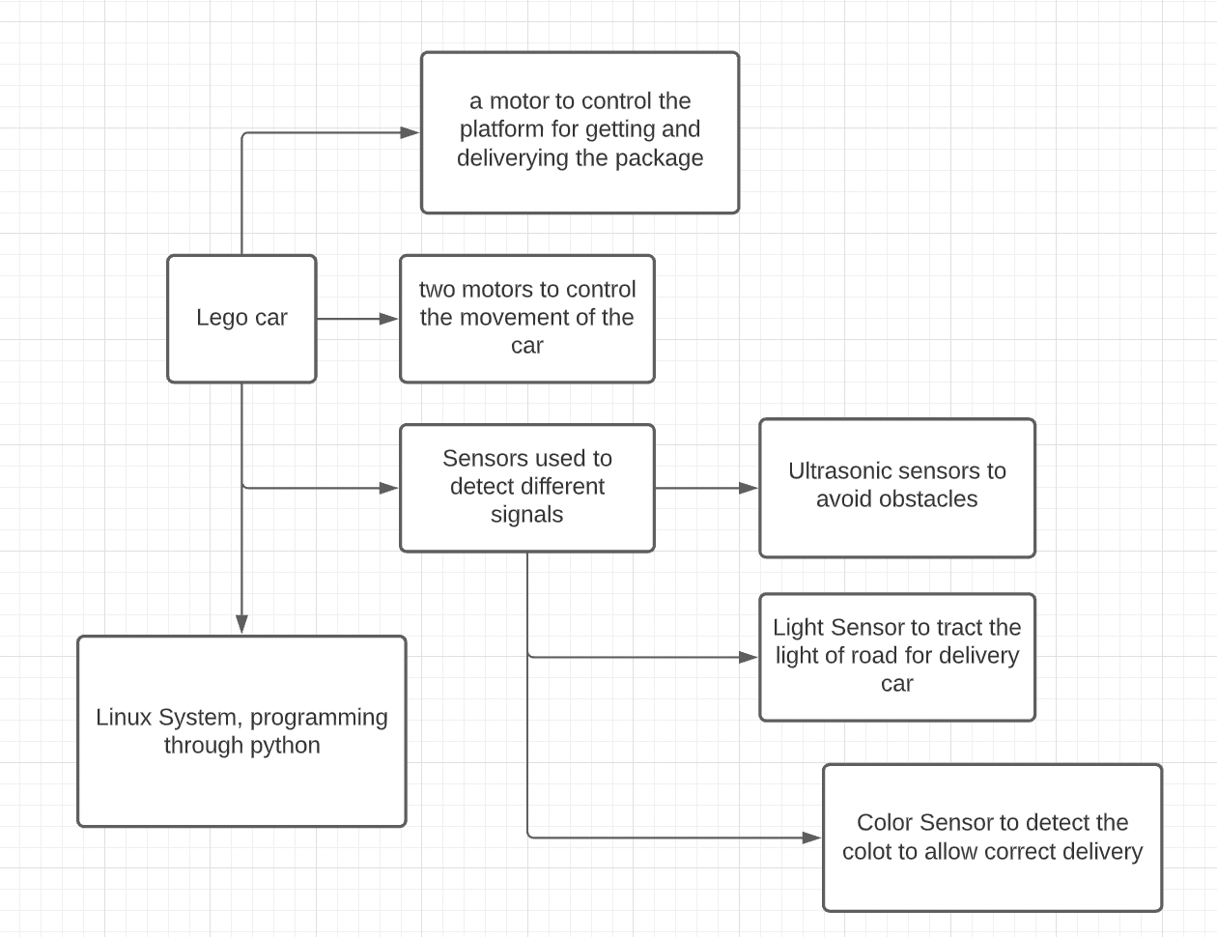

Include the list of the components/parts used so far. For each component, include the part #, a short description and the quantity used in the project. As an example:

|  |  |  |
| --- | --- | --- |
| **Part #** | **Description** | **Quantity used** |
| HC-SR04 | Ultrasonic Range Finder Sensor Module | 1 |
| Lego EV3 Vrick | The heart/brain of the cart | 1 |
| light sensor | Detecting route and houses | 2 |
| Medium size motor | Wheels of the cart | 2 |
| Larger size motor | For package pick up and drop off | 2 |

Lego EV3 Vrick x1:

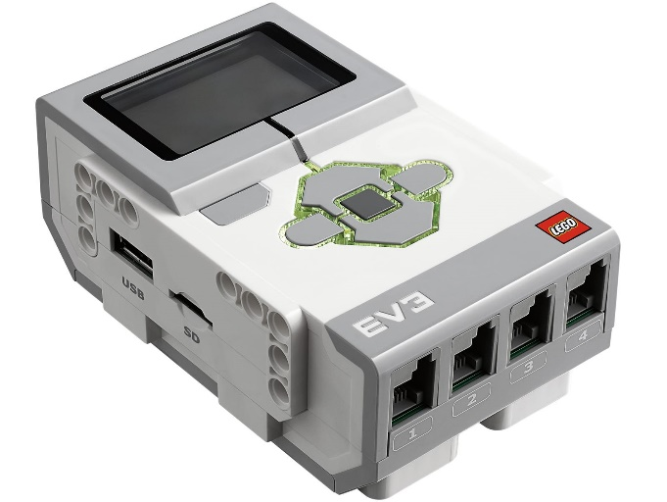

Ultrasonic sensor x1, light sensor x1, and gyroscope sensor x1

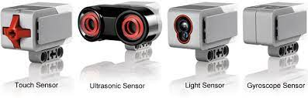

Medium size motor x2 (left) Larger size motor x2 (right)

